

|  |  |  |
| --- | --- | --- |
| Hazard Communications Program | Related Policies: | |
| *This policy is for internal use only and does not enlarge an employee’s civil liability in any way. The policy should not be construed as creating a higher duty of care, in an evidentiary sense, with respect to third party civil claims against employees. A violation of this policy, if proven, can only form the basis of a complaint by this department for non-judicial administrative action in accordance with the laws governing employee discipline.* | | |
| Applicable KY Statutes: KRS Ch. 39E  Applicable KY Regulations: 106 KAR Chapter 1 | | |
| OSHA: 29 CFR 1910.1200 | | |
| NFPA Standard: 1500, 472 | | |
| Date Implemented: | | Review Date: |

1. **Policy:** The Fire Department shall maintain an effective Hazard Communication Program that meets the requirements of 29 CFR 1910.1200 in order to ensure the hazards of all chemicals used in the Fire Department are evaluated and information concerning the chemical hazards is provided to the employees.
2. **Purpose:** To provide for the safety of members who may be exposed to chemicals in the workplace and to ensure compliance with the applicable OSHA Regulations.
3. **Scope:** This program applies to all personnel, fire stations and fire department facilities where employees may be exposed to hazardous substances under normal working conditions or during an emergency situation.
4. **Definitions**

Chemical – any substance, or mixture of substances. Exposure to chemicals can be in a variety of forms such as; solids, liquids, gases, dusts, mists, or fumes.

Exposure (or Exposed) – means that an employee is subjected in the course of employment to a chemical that is a physical or health hazard, and includes potential, e.g. accidental or possible exposure. "Subjected" in terms of health hazards includes any route of entry, e.g. inhalation, ingestion, skin contact or absorption.

Hazard Category – the division of criteria within each hazard class, e.g., oral acute toxicity and flammable liquids include four hazard categories. These categories compare hazard severity within a hazard class and should not be taken as a comparison of hazard categories more generally.

Hazard Class – the nature of the physical or health hazards, e.g., flammable solid, carcinogen, oral acute toxicity.

Hazard Not Otherwise Classified (HNOC) – an adverse physical or health effect identified through evaluation of scientific evidence during the classification process that does not meet the specified criteria for the physical and health hazard classes.

Hazard Statement – a statement assigned to a hazard class and category that describes the nature of the hazard(s) of a chemical, including, where appropriate, the degree of hazard.

Hazardous Chemical – any chemical which is classified as a physical hazard, or a health hazard, a simple asphyxiant, combustible dust, pyrophoric gas, or hazard not otherwise classified (HNOC). For example, compressed gas is considered a physical hazard and wood dust is considered a health hazard.

HAZCOM - Hazard Communication

Health Hazard – a chemical which is classified as posing one of the following hazardous effects: acute toxicity (any route of exposure); skin corrosion or irritation; serious eye damage or eye irritation; respiratory or skin sensitization; germ cell mutagenicity; carcinogenicity; reproductive toxicity; specific target organ toxicity (single or repeated exposure); or aspiration hazard.

Label – an appropriate group of written, printed or graphic information elements concerning a hazardous chemical that is affixed to, printed on, or attached to the immediate container of a hazardous chemical, or to the outside packaging.

Mixture – a combination or a solution composed of two or more substances in which they do not react.

Personal Protective Equipment (PPE) – devices worn by the worker to protect against hazards in the environment. Examples include safety glasses, face shields, respirators, gloves, hard hats, steel-toed shoes, and hearing protection.

Physical Hazard – a chemical that is classified as posing one of the following hazardous effects: explosive; flammable (gases, aerosols, liquids, or solids); oxidizer (liquid, solid or gas); self-reactive; pyrophoric (liquid or solid); self-heating; organic peroxide; corrosive to metal; gas under pressure; or in contact with water emits flammable gas.

Pictogram – a composition that may include a symbol plus other graphic elements, such as a border, background pattern, or color, that is intended to convey specific information about the hazards of a chemical. As of June 1, 2015, the Hazard Communication Standard (HCS) will require pictograms on labels to alert users of the chemical hazards to which they may be exposed. Each pictogram consists of a symbol on a white background framed within a red border and represents a distinct hazard(s). The pictogram on the label is determined by the chemical hazard classification.

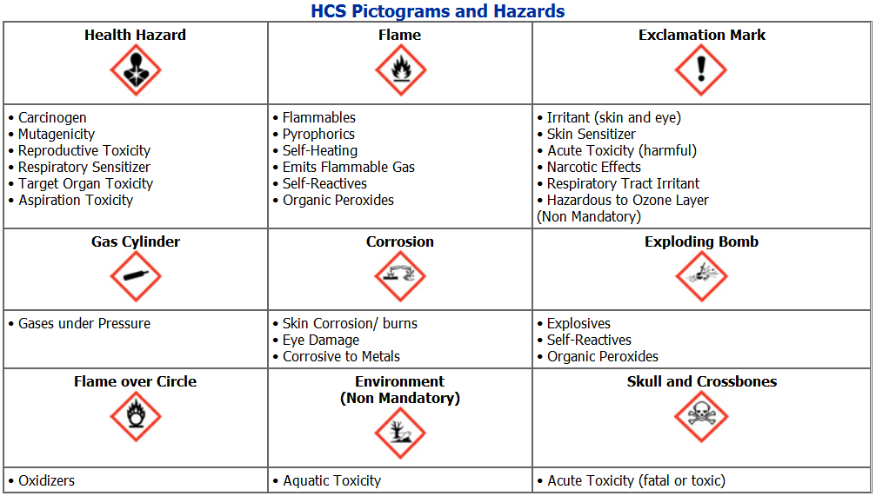

Precautionary Statement – a phrase that describes recommended measures that should be taken to minimize or prevent adverse effects resulting from exposure to a hazardous chemical, or improper storage or handling.

Pyrophoric Gas – a chemical in a gaseous state that will ignite spontaneously in air at a temperature of 130°F (54.4°C) or below.

Safety Data Sheet (SDS) – written or printed material concerning a hazardous chemical that serves as an informational tool developed by chemical manufacturers containing the following information for a hazardous chemical: product identification, use restrictions, hazards identification, chemical ingredients, first-aid measures, fire-fighting measures, accidental release measures, handling & storage information, physical & chemical properties, stability & reactivity information and toxicological information. SDS are in a standardized, 16-section format and can be obtained from the chemical suppliers and many internet sites.

Signal Word – a word used to indicate the relative level of severity of hazard and alert the reader to a potential hazard on the label. The signal words used in this section are "danger" and "warning." "Danger" is used for the more severe hazards, while "warning" is used for the less severe.

Simple Asphyxiant – a substance or mixture that displaces oxygen in the ambient atmosphere, and can thus cause oxygen deprivation in those who are exposed, leading to unconsciousness and death.

Substance – chemical elements and their compounds in the natural state or obtained by any production process, including any additive necessary to preserve the stability of the product and any impurities deriving from the process used, but excluding any solvent which may be separated without affecting the stability of the substance or changing its composition.

Trade Secret – any confidential formula, pattern, process, device, information or compilation of information that is used in an employer's business, and that gives the employer an opportunity to obtain an advantage over competitors who do not know or use it.

Use – to package, handle, react, emit, extract, generate as a byproduct, or transfer.

1. **Safety Data Sheets (SDS)**
2. The Fire Department will obtain an SDS for each hazardous chemical that is purchased and stocked by the Fire Department. Food, drugs and cosmetics brought into the workplace for employee consumption are exempt.
3. An SDS will be provided for all each hazardous chemical present within the department. SDSs will be provided in two formats: hardcopy and electronic.
4. Hard copies of all SDS shall be maintained at the location where the hazardous chemical is stored and/or used.
5. Electronic copies of SDS information shall be available to all personnel on the fire department computer system.
6. **Labels and Other Forms of Warning**
7. All hazardous chemical containers used in fire stations or fire department facilities will either contain the original manufacturer’s label --that includes a product identifier, an appropriate signal word, hazard statement(s), pictogram(s), precautionary statement(s) and the name, address, and telephone number of the chemical manufacturer, importer, or other responsible party -- OR a label with the appropriate label elements just described; OR workplace labeling that includes the product identifier and words, pictures, symbols, or combination that provide at least general information regarding the hazards of the chemicals.
8. Labels must list in English the chemical identity, appropriate hazard warnings, and the name and address of the manufacturer.
9. Information may be added in other languages as long as the information is available in English as well.
10. Labels need to be legible and prominently displayed, though the size and color can vary.
11. Labels shall not be removed or defaced. Containers of hazardous chemicals with labels that are removed or defaced shall not be used, and shall be promptly reported to the Fire Department Safety Officer for prompt identification and disposal.
12. Shipments or deliveries of unlabeled containers of hazardous chemicals shall not be accepted or allowed onto fire department property.
13. Hazardous chemicals shall not be placed into unlabeled containers.
14. **Employee Information and Training**
15. Employees will be provided with information and training on the hazardous chemicals in their work area at the time of their initial assignment and before they come into contact with or are exposed to the chemical in the workplace.
16. Additional training will also be provided whenever a new hazardous chemical is introduced into the work area, which has not previously been included in training.
17. HAZCOM Training will include information on the following:
18. The requirements of 29 CFR 1910.1200
19. How to access this written program, the work area inventory lists and the SDSs for hazardous chemicals used in the work area
20. Appendix A and B of the HAZCOM standard (29 CFR 1910.1200)
21. Operations that involve the use of hazardous chemicals.
22. Emergency procedures to follow in the event of an accidental spill or release of hazardous chemical
23. How to detect potential exposures, the presence or release of a hazardous chemical in the work area, or possible exposures to hazardous chemicals in the workplace
24. The physical and health hazards of the hazardous chemicals used within the Fire Department
25. The specific procedures that personnel are required to take to protect themselves from these hazards, including specific procedures to protect personnel from exposure to hazardous chemicals, such as appropriate work practices, emergency procedures, and use of proper personal protective equipment (PPE)
26. Details of the Fire Department Written HAZCOM program, including an explanation of SDSs and product labeling
27. How to access SDSs on Fire Department computers
28. Employees will be advised upon initial assignment of any operations in their work area where hazardous chemicals are present and the location and availability of the written Hazard Communication Program, including the inventory of hazardous chemicals and associated Safety Data Sheets.
29. Before any employee is asked to perform any non-routine tasks that are hazardous (e.g., entering confined spaces, cleaning empty hazardous chemical containers, etc.) a special training session shall be conducted prior to starting work on such tasks. Such training will cover, at a minimum, the following elements:
    * 1. the hazardous chemicals that may be encountered during such task
      2. an explanation of the appropriate precautions to take
      3. an explanation of the steps the fire department is taking to reduce hazards
      4. an explanation of emergency procedures
30. Firefighter Recruits
31. The Fire Department will provide Hazard Communication Training to new Firefighter Recruits while they are in training.
32. New Civilian Employees
33. New civilian employees shall receive Hazard Communication Training during the new employee orientation training.
34. Current Employees
35. Refresher training shall be provided to all employees annually.
36. Additional HAZCOM training will be provided to all employees when new hazardous products are introduced into their work area.
37. All training shall be documented in writing or via electronic means, and such documentation shall be maintained for at least thirty (30) years.
38. **Responsibilities**
39. Fire Department Safety Officer’s Responsibility. The Fire Department Safety Officer is the Hazardous Communication Program Administrator and is responsible to:
40. Maintain, update and perform an annual review of the Hazardous Communication Program.
41. Coordinate the annual chemical inventory, listing all hazardous chemicals known to be present in each workplace together with the maximum volumes, and approve all related work practices associated with the chemicals.
42. Conduct an audit of Safety Data Sheets, obtain copies of any SDS for products without one, and notify the Fire Chief of any deficiencies in SDS availability in the workplace.
43. Ensure employees receive Hazard Communication – Right to Know training
44. Ensure employees receive training on the chemicals used upon initial assignment and when new chemicals are added.
45. Ensure employees are advised of the location and availability of the written hazard communication program, including the required list(s) of hazardous chemicals and Safety Data Sheets required by this section.
46. Ensure that the most CURRENT updated hardcopies of SDSs are obtained and maintained at each work site, along with a listing of all hazardous chemicals present.
47. Ensure that SDSs are maintained for at least thirty (30) years.
48. Ensure that the name of any hazardous chemical brought into a fire station or fire department facility by a contractor is promptly identified, and a Safety Data Sheet for the chemical is obtained.

**EDITOR’s Note:** The safety officer is one of the most logical officers to assign this responsibility to, but others may include: Hazardous Materials Officer, Special Operations Officers, Training Officer, or even a Hazardous Materials Inspector.

1. Fire Department Administrative Responsibility
2. When chemicals are delivered to the Fire Department from the manufacturer or distributor, the member accepting delivery shall inspect the container to ensure labels are affixed and Safety Data Sheets have been supplied.
3. Employee’s Responsibility
4. Attend all hazard communication training as directed.
5. Become familiar with the safe handling procedures and emergency situation procedures (as provided on the various labels, instructions and/or Safety Data Sheets) for chemicals prior to using the chemical.
6. Ensure all work site containers of hazardous chemicals are labeled, tagged or marked with the identity of the material and appropriate hazard warnings.
7. Utilize personal protective equipment (PPE) recommended and/or required by the manufacturer of the chemical.
8. Employees shall not perform non-routine tasks involving hazardous chemicals or material without first receiving training. No employee shall place himself or herself at risk in the performance of any chemical-related or other task.
9. Employees who become discover a hazardous chemical present in the workplace that is not on the inventory list, whether through delivery by a third party, being brought in by a contractor, or for some other reason, shall promptly notify the Fire Department Safety Officer through the chain of command.